Raport
I. Configurarea instrumentului de migrare
Entity Framework Core
dotnet tool install --global dotnet-ef
dotnet ef migrations add InitialCreate
II. Migrare initiala
Migrarea initiala a fost creata la pasul anterior prin comanda
dotnet ef migrations add InitialCreate
III. Adaugare coloana noua
In a doua migrare, am adaugat o coloana pentru numarul de telefon al unui angajat.
Prima data, am modificat entitatea Employee, adaugand urmatorul field (si anotarile):
[MaxLength(10)]
[Column("phone_number")]
public string? PhoneNumber { get; set; }
Dupa care, am generat o noua migrare folosind comanda
dotnet ef migrations add AddedEmployeePhoneNumber
IV. Adaugare tabel nou
In a treia migrare, am adaugat un tabel nou care retine proiectele unui departament.
Prima data, am adaugat entitatea Project in proiect:
[Table("projects")]
public class Project(string name, string description, long departmentId) : IEntity<long>
{
[Key]
[Column("id")]
[DatabaseGenerated(DatabaseGeneratedOption.Identity)]
public long Id { get; set; } = 0;
[Required]
[MaxLength(50)]
[Column("name")]
public string Name { get; set; } = name;
[Required]
[MaxLength(250)]
[Column("description")]
public string Description { get; set; } = description;
[Column("department_id")]
public long DepartmentId { get; set; } = departmentId;
[ForeignKey("DepartmentId")]
public virtual Department Department { get; set; }
}
Dupa care am creat o noua migrare folosind comanda
dotnet ef migrations add AddedProjectEntity
V. Adaugare indexuri
In prima faza am modificat entitatea Employee adaugand anotarea pentru precision
[Precision(18, 2)]
Dupa care am creat o noua migrare folosind comanda
dotnet ef migrations add AddedProjectEntity
VI. Adaugare Optimistic Locking
In prima faza am modificat entitatea Employee adaugand un field nou care retine versiunea curenta a entitatii
[Timestamp]
public byte[] RowVersion { get; set; }
Dupa care am creat o noua migrare folosind comanda
dotnet ef migrations add AddedOptimisticLockingForEmployee
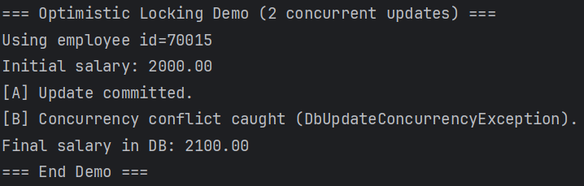
VII. Implementare stergere soft
In prima faza am modificat entitatea Employee adaugand un field nou care retine daca entitatea este stearsa sau nu
[Column("is_deleted")]
public bool IsDeleted { get; set; } = false;
Dupa care am creat o noua migrare folosind comanda
dotnet ef migrations add AddedSoftDeleteForEmployee
Apoi am modificat toate operatiile de stergere si filtrare a entitatilor Employee din repository si service
VIII. Implementare audit log
Am adaugat o entitate noua, AuditLog
[Table("audit_logs")]
public class AuditLog(string entityName, long entityId, string deletedBy, string deleteType)
: IEntity<long>
{
[Key]
[Column("id")]
[DatabaseGenerated(DatabaseGeneratedOption.Identity)]
public long Id { get; set; } = 0;
[Required]
[MaxLength(100)]
[Column("entity_name")]
public string EntityName { get; set; } = entityName;
[Column("entity_id")]
public long EntityId { get; set; } = entityId;
[Required]
[MaxLength(100)]
[Column("deleted_by")]
public string DeletedBy { get; set; } = deletedBy;
[Required]
[MaxLength(20)]
[Column("delete_type")]
public string DeleteType { get; set; } = deleteType;
[Column("deleted_at")]
public DateTime DeletedAt { get; set; } = DateTime.UtcNow;
}
Dupa care am creat o noua migrare pentru aceasta entitate. Am creat o clasa noua, AuditTrailLogger, prin care fac logging pentru operatiile de delete. Am adaugat utilizarea acestei clase in toate locurile unde se face delete.

